The relation between pain and muscle activity in participants with a history of low back pain and healthy participants.

Dear participant,

We would like to invite you to take part in our research. In this letter, we inform you about the present research study. Specifically, we will talk about its goals, the data we would like to collect, how much time and effort we ask from you, and the possible benefits and disadvantages of participation. Please read the following information carefully and ask the researcher for more information if you have any questions.

After you have read the information and your questions have been answered, you can decide if you want to participate in this study. Your participation is entirely voluntary. If you decide to participate, please sign the consent form attached.

1. Research goal

The aim of this study is to investigate the effect of pain inhibition in the brain on muscle activity and sensitivity to heat in participants with a history of low back pain and healthy people.
Conditioned pain modulation (CPM), also known as the 'pain-inhibits-pain' phenomenon, assumes that pain perception decreases when a second painful stimulus is applied. This phenomenon activates the pain-inhibiting mechanisms in the brain with the aim of reducing your pain.
It is unclear whether this pain-inhibiting capacity also influences muscle activity. Therefore, we want to investigate the influence of this pain-inhibiting capacity on muscle activity and sensitivity to heat in participants with a history of low back pain and healthy people.
This research is being carried out by the Department of Behavioral and Movement Sciences at VU University Amsterdam.

2. Study background

Experimentally induced pain has been shown to provoke immediate changes within brain connections. It has also been shown that these changes, if prolonged can lead to chronic pain and adjustment of movements performed during daily life activities.
Conditioned pain modulation (CPM), known as a pain inhibition phenomenon, also showed to have an impact on muscle reflexes. However, the CPM effect on voluntary muscle activity is still not investigated.
Therefore, the insight we gain from this study will be useful better to understand the influence of pain-inhibiting capacity on voluntary muscle activity.

3. What will happen during this study

Step 1: Are you eligible to participate?

We first want to know if you are eligible to participate in the study. That is why the researcher will ask you a number of questions. You can participate if you:
- are between 18 and 65 years old
- understand the Dutch or English language
- have a history of low back pain but pain-free in the last 3 months
- or healthy.

Furthermore, you may not be familiar with diseases such as cardiovascular disease, diabetes mellitus, depression or an anxiety disorder, rheumatism, previous surgery on your back, hypersensitivity to cold and/or hot stimuli, or being pregnant.

Step 2: Research design

The study will be conducted in one meeting and is expected to take approximately 80 minutes, excluding travelling time to the Vrije Universiteit Amsterdam. If you participate in this study, a number of tests will be carried out with which we want to measure the effect of the pain-inhibiting capacity on muscle activity and the sensitivity to heat (part 1 and part 3). In addition, we ask you to complete a number of questionnaires about your state of health. These questionnaires are not (psychologically) stressful for you (part 2).
Part 1:
The first part consists of a test that takes about 40 minutes.
During the measurement, a pushing machine will give you 5 perturbations to your back under different conditions. You will be asked to “resist the perturbations to maintain the neutral position” (see Figure 1).
The test starts by determining when your feeling of warmth turns into an unpleasant feeling. For this, we place a sensor on your arm. You press a button, and the test stops. With this, we determine the threshold at which heat turns into an unpleasant feeling.
- In situation 2, your individual heat stimulus is applied to your back, and you are asked to score the sensitivity on an 11-point numeric pain rating scale (0 = no pain – 10= unbearable pain).
- Situation 3 is the same as situation 2, where you are asked to dip your dominant (=your writing hand) hand in a cold water bath (~9 °C) for 60 seconds.
- Situation 4 is the same as situation 2, except that the heat stimulus is applied to your non-dominant forearm
- Situation 5 is the same as situation 4, where you again have to dip your dominant hand in a cold water bath (~9 °C) for 60 seconds.
After each disturbance, you will be asked to score the sensitivity to heat (on the back or the forearm) on an 11-point numeric pain rating scale.
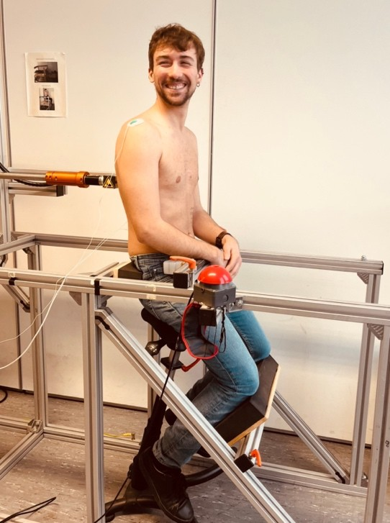

Figure 1: perturbations to the back.

Part 2:
The second part consists of completing a number of questionnaires. This takes about 15 minutes. The researcher will be present if you have any questions.

Part 3:
The third part consists of a test that will take about 10 minutes. Here, you are asked to bend forward five times maximum with the fingers to the floor without bending your knees. We will also ask you this when you receive the heat stimulus and your foot is in a cold water bath.

4. What we expect from you

In order for the research to run smoothly, it is important that you keep to the following agreements. We ask that you:
- follow the instructions of the researcher
- keep appointments for the visit
- do not perform strenuous physical activity within 24 hours before the measurement.
- do not take any analgesic medication (painkillers) within 24 hours before the measurement such as acetaminophen or nonsteroidal anti-inflammatory drugs.

It is important that you contact the researcher if:
- you no longer wish to participate in the research, this is always allowed and without giving any reason
- change your contact details.

5. Possible benefits and disadvantages

You will probably not benefit directly from participating in this study. The research may provide useful data for the future. Your participation contributes to more knowledge about the pain-inhibiting capacity and its influence on the muscles. With this, we can better understand muscle tension in back pain and how we can influence this.
Disadvantages of participating in the study can be:
• Extra time it will cost you. This research involves a time investment of 80 minutes, excluding travel time to the Vrije Universiteit Amsterdam.
• Some test stimuli may be experienced as uncomfortable or unpleasant.
• The application of the heat stimulus may cause some temporary redness to appear on your skin.

6. When you do not want to participate or want to withdraw from the study

You decide whether you want to participate in the study. Your participation is entirely
voluntary. When you do not want to participate, you do not need to do anything or sign anything. You do not have to tell us why you do not want to participate. When you decide to participate, you can always change your mind and withdraw your participation. You can also withdraw participation during the study. The data collected up to that point will be used for the research.

7. When this study will end

Your participation in the study ends when all measurements are taken, if you choose to withdraw, or when the researcher decides it is better for you to no longer participate. The study, in general, will end when all participants have taken part in it.

8. Processing and storage of your data

Which data are collected?
Your personal data is collected, used and stored for this research. This concerns data such as your name, date of birth, biological sex and data about your health. The collection, use and storage of your data is necessary to answer the questions asked in this study and to publish the results. We ask for your permission for the use of your data.

How do we protect your privacy?
To protect your privacy, we use a code that is matched to your personal data and only use the code, and not any of your personal data like your name, when processing the data. The code is stored in a secure place at the university, and only the researchers have access to this. The same applies to reports and publications, so no one will be able to find out that the results are about you. All your data will remain confidential. Only the involved researchers will know your code. The code will remain with the principal investigators.

Who has access to your data?
Some people have access to your personal data. This is to check whether the research is conducted correctly and is reliable. People that have access to your data are members of the safety monitoring committee and the research team. Sometimes students are also part of the research team. Students sign a privacy statement beforehand if they have access to the data. Those with access to your data will keep it confidential. If you sign the consent form, you consent to collection, storage and access of your personal data by these people.

For how long do we store your data?
The researchers are required by law to store your data for the duration of 10 years.

9. Compensation for participation

Participation in the study will not involve any costs for you. You will not be paid for participating in this study.

10. Ethical review and complaints

This research is evaluated by The Scientific and Ethical Review Board (VCWE) of the Faculty of Behavioural and Movement Sciences, Vrije Universiteit Amsterdam and is in line with the ethical guidelines of the faculty. In case of complaints, please contact the researcher first. When this does not solve the issue, you can submit a complaint via vcwe.fgb@vu.nl. If you have any questions about the privacy of your data, please contact functionarisgegevensbescherming@vu.nl

11. Do you have questions?

If you have any questions, please contact the members of the research team.
(See appendix A.)

12. How do you provide consent to take part in this study?

You can take a moment to consider whether you want to take part. Then you can tell the researcher whether you understand the information provided and whether you want to participate. Do you want to participate? Then please sign the consent form that is attached to this information letter (see appendix B).

Appendix A: Research team, contact information
Appendix B: Information letter

Appendix A: Research team, contact information

(Local) researcher
Name: Xianhua Zeng
Position: researcher
Tel: 0626038780
Email: x.zeng@vu.nl

Researcher (coordinator)
Name: dr. René Castien
Position: coordinator/researcher
Tel: 0650231808
Email: r.f.castien@vu.nl

Principle investigator VU
Name: dr. Wendy Scholten-Peeters
Position: principle researcher
Tel: 020 5988557
Email: g.g.m.scholten-peeters@vu.nl

Appendix B: Information letter

The relation between pain and muscle activity in participants with a history of low back pain and healthy participants.

Principle investigator: Name: dr. Wendy Scholten-Peeters
email: g.g.m.scholten-peeters@vu.nl
tel: 020 5988557

Researcher : Name: Xianhua Zeng
email: x.zeng@vu.nl
tel: 0626038780

Dear participant,

Please read this form carefully. If you agree with the statements, you can sign the form below.

Read and signed by research participant

- I confirm that I have read the participant information sheet for this study. I was able to ask questions. My questions have been answered to my satisfaction. I was given sufficient time to decide whether I want to participate.

- I understand that participation is voluntary and that I am free to withdraw at any time, without providing a reason for doing so.

- I consent to the collection and processing of my data. The data I provide will only be used to answer the research question of this research project.

- Students are involved in this study as part of their internship and therefore have acces to my personal data, after they have signed a privacy statement. I consent to providing these students with access to my personal data.

- I understand that my data will be kept confidential. I am also aware that only de-identified results of this study will be communicated to third parties.

- I consent to save my data for 10 years after I have participated

- I want to participate in this study

Researchers are allowed to contact me for follow-up studies
☐ Yes
☐ No

I consent to using my de-identified data for similar research studies.
☐ Yes
☐ No

Name of participant:

Signature: Date : __ / __ / __
-----------------------------------------------------------------------------------------------------------------

Signed by researcher

I declare that I have fully informed the participant about this research

When new information becomes available during data collection that may influence participants’ consent, I will inform them immediately.

Name of researcher:
Signature: Date: __ / __ / __
-----------------------------------------------------------------------------------------------------------------

Participants should receive the information sheet and a copy of the signed consent form.

